Daytime Layout

## Before Opening Tent

* Put away extra chairs put out in evening service
* IF DRY, remove Tarp from outside chairs
* IAN ─ Check money bags status … else get more from NATWEST
* Put out Tea/Coffee on table with donations bucket/jar
* Put out 20 chairs around edge
* Put out collection bucket on stage
* Hand out badges and lanyards

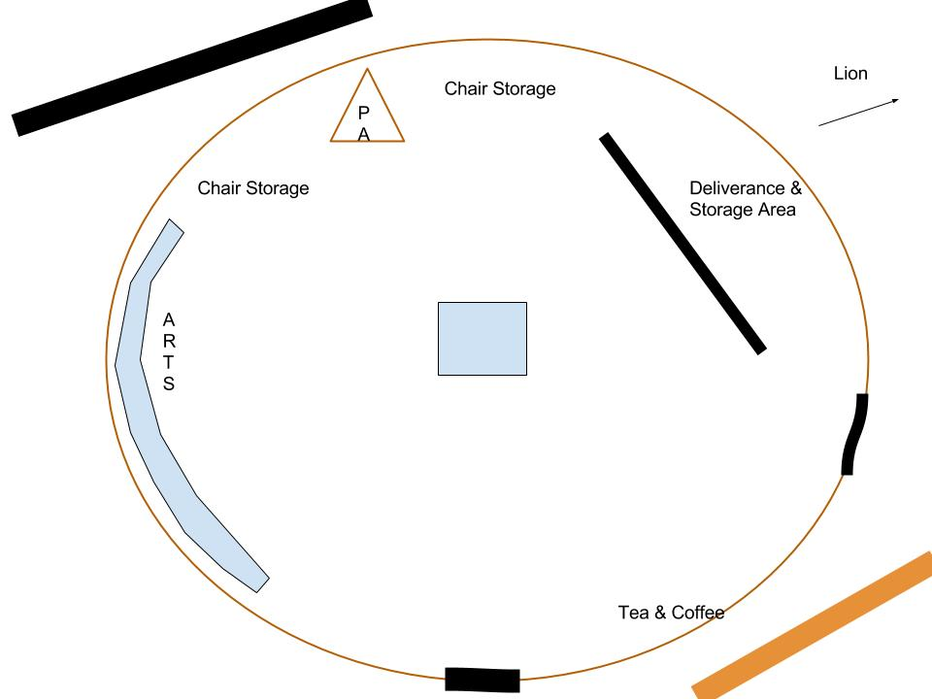

## During Afternoon Session

* Regularly collect money from refreshments area and stage collection bucket and take to bus and hand over to evangelism team ─ who will keep safe
* Regular housekeeping

After Afternoon Sessions

* Collect badges and lanyards